**Project:**

**Find match : Find your love**

**Subject : Automated Software Testing**

**Mentor : Pargol Poshtareh**

**Team Members [Team-8]:**

Roshni Parmar-209473

Hitikshaben Raj-2091994

| **Table Of content** | | |
| --- | --- | --- |
| **No.** | **Topic** | **Page No.** |
| 1 | [Description](https://docs.google.com/document/d/1dghCuOYcCZLI1LfWi4UZ9B3B2yYggxgTTO7zHhXNJ0M/edit#heading=h.igpy1g1dbg2y) | 2 |
| 2 | [Scope](https://docs.google.com/document/d/1dghCuOYcCZLI1LfWi4UZ9B3B2yYggxgTTO7zHhXNJ0M/edit#heading=h.nn4gobhpt8tg) | 2 |
| 3 | Function Requirement | 16 |
| 4 | Non Functional Requirements | 16 |
| 5 | Flow Chart | 17 |
| 6 | User Story | 19 |
| /7 | Use Case Diagram | 24 |
| 8 | Fully Dressed Use Case | 25 |
| 9 | Activity Diagram | 29 |
| 10 | Sequence Diagram | 30 |
| 11 | Test Cases | 31 |
|  |  |  |
|  |  |  |

**Project: Find your match**

**Description**:

This website aims to provide information of people , who want to find friend and partner .Here no organisation is included, with the help of it you can not only make friends but also find love of your life in this modern era.Moreover its free of cost website for all who love to talk .This website gather the information most relevant to person’s decision and invest in their love life .looking for someone who has same interest and motivation is hard so here this website will help you.

**Scope**:

Spreading love and improving relation reach.Providing 24*7 access to the customer.Records of the customer’s information can help better manage the resources in the website.The website will contain two types of Users Admin and Customer.the customer will have limited access.In contrast Admin will have more access as she will be able to manage the profile of people.

**Moqups:**

<https://app.moqups.com/ExD2BtYvsG5enV2TYFsqFePcStzQfKaw/view/page/ad64222d5>

**HOME**

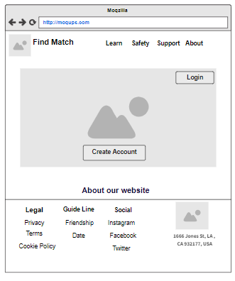

**LOGIN**

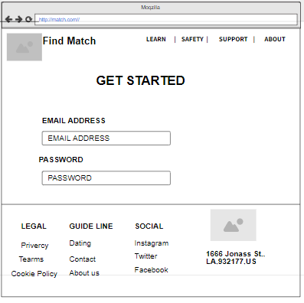

**SIGN UP**

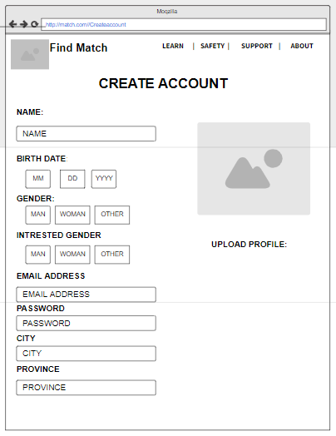

**Find match**

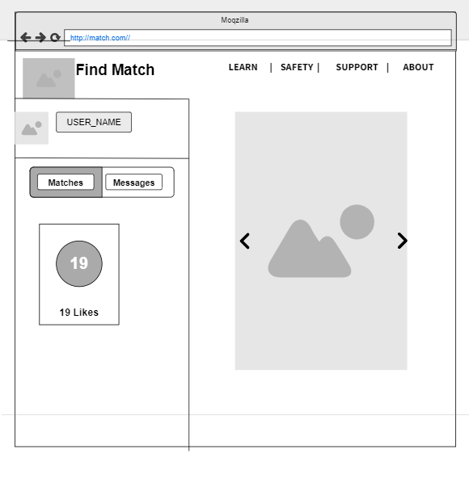

**MATCH PEOPLE**

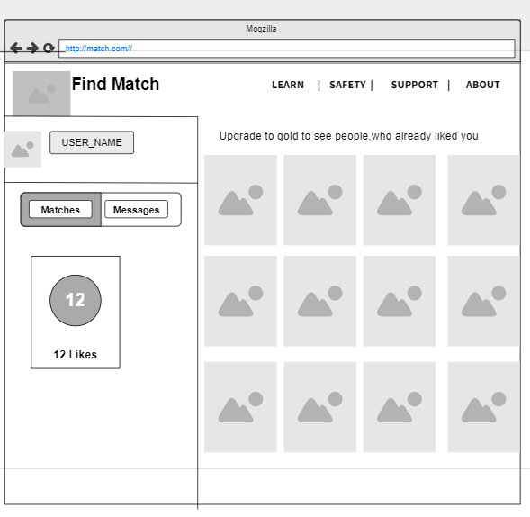

**PROFILE OF MATCH**

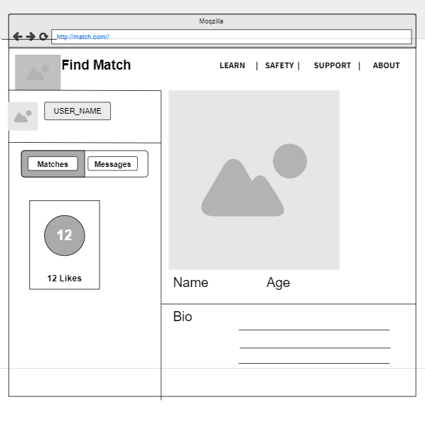

**MY PROFILE**

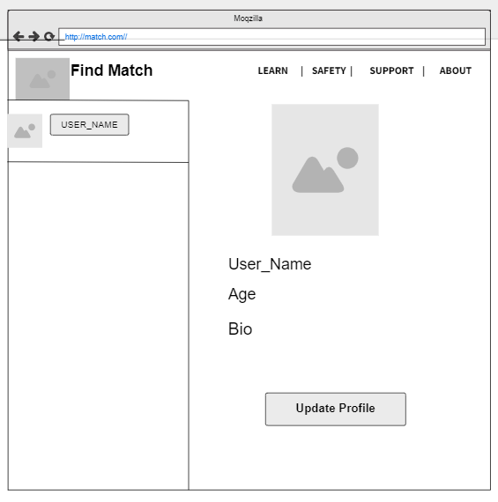

**MESSAGES**

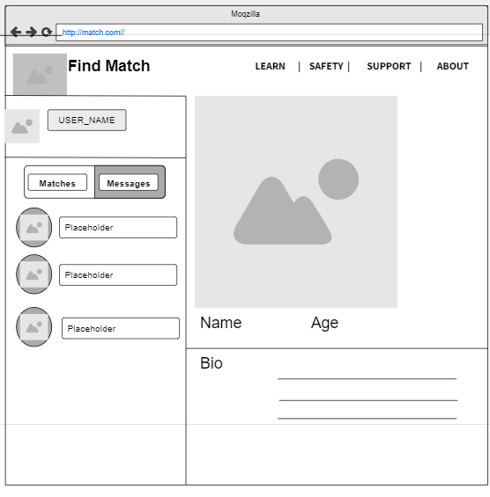

**UPDATE USER INFORMATION**

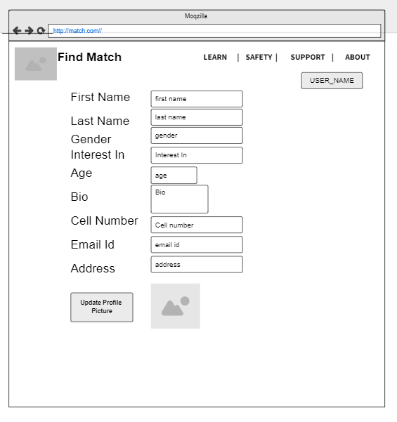

**CONTACT US**

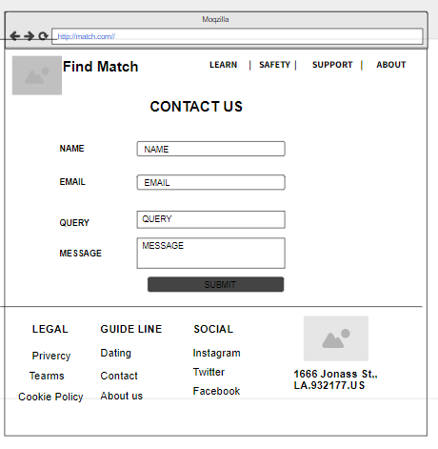

**REVIEW PAGE**

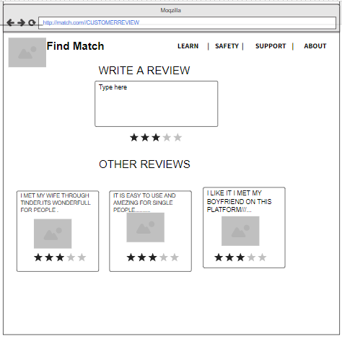

**ADMIN PANEL**

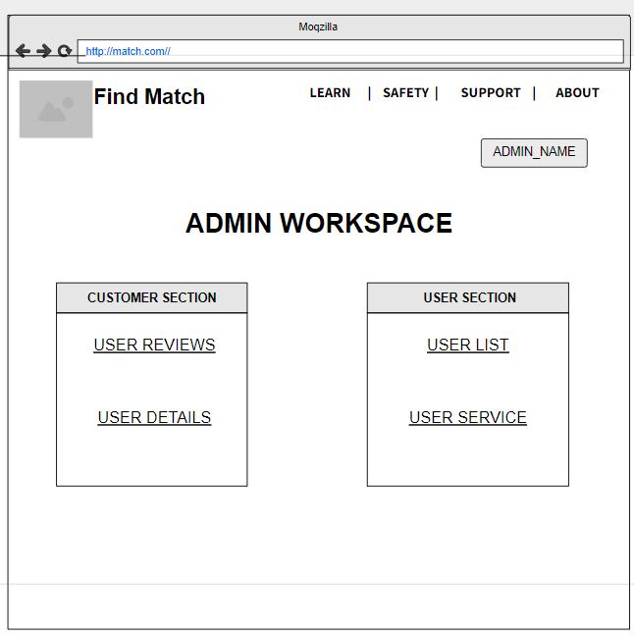

**UPDATE USER PANEL (ADMIN)**

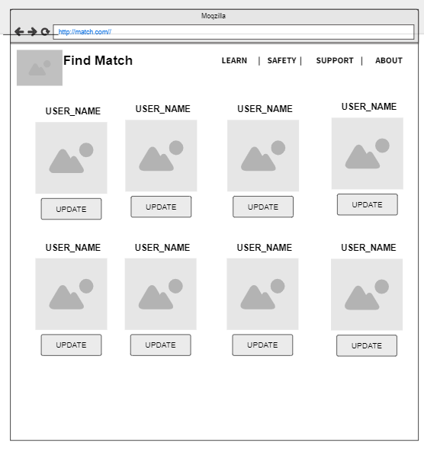

**Functional Requirements:**

1. Users must be able to provide profile info and browser profiles of other single users that include birthday(sign),age,location and other personal traits.
2. The user can make changes to the profile after creating an account.
3. The user is able to like the profile of interested people.
4. The user can see more features of the website and can chat with people.(If both swipe right then only).
5. The admin is able to add or edit user’s details
6. The admin is able to remove suspicious users from registered users.
7. The user is able to give a review and ask a question(query) about the website..

**Non-Functional Requirement:**

1. The website should be responsive & reactive with the chrome browser.
2. Databases (mysql) must be secure so that there is no breach of any data.
3. The delay for loading each page should be minimum.
4. The user is unable to get access to the admin section.
5. The website is scalable to support multiple users while maintaining the performance.
6. The website runs on node js server and uses mysql as a database to store and maintain data.
7. The password input must meet the specified criteria.

**FLOW CHART:**

**USER SIDE:**

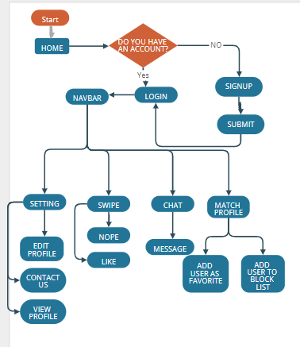

**ADMIN SIDE:**

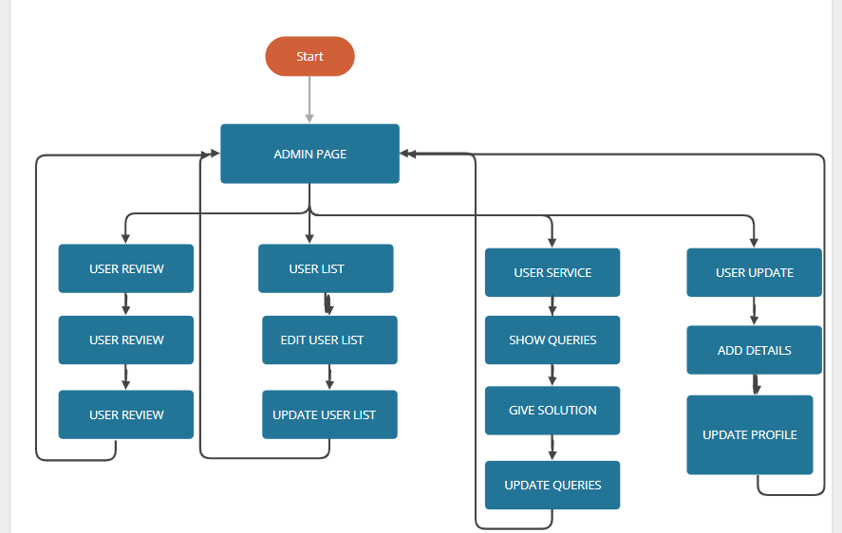

**USER STORIES:**

| **USER STORIES** | | | |
| --- | --- | --- | --- |
| **Story No.** | **Description** | **Points** | **Priority** |
| US1 | As a guest User,I can register myself so that I can continue with the sign up process. | 3 | M |
| US2 | As a registered login user I want to click sign out so that I am able to logout successfully out of the website. | 3 | L |
| US3 | As a login user I can see different people according to my choice . | 8 | H |
| US4 | As a user I should be able to check a profile of people. | 5 | M |
| US5 | As a registered user I can login to my account so that I can match the people, in whom the user is interested. | 5 | M |
| US6 | As a loginned user I should be able to upload my profile photo. | 3 | L |
| US7 | As a user I can change my password so that I can secure my account. | 5 | M |
| US8 | As a user i can upload my multiple photos | 2 | L |
| US9 | As a loginned user I want to click on user info so that I am able to view my user details stored on the website. | 3 | L |
| US10 | As a user, I get more features of the website. | 13 | H |
| US11 | As a user, I should be able to message with the person who is in the match list . | 8 | H |
| US12 | As a user, I can see the people who already liked you . | 8 | H |
| US13 | As a user, I can do unlimited rematch. | 5 | M |
| US14 | As a user, I can add my review so that I can share my experience. | 3 | L |
| US15 | As a registered User I can navigate through all the webpages so that I can go through all the features of the website and use it. | 2 | L |
| US16 | As a user, I should be able to get help from the contact us page. | 5 | M |
| US17 | As an admin I can login into my account so that I can use my admin rights. | 8 | H |
| US18 | As a user ,if it's the right swipe from both sides then it would be a message on the profile option to chat. | 8 | H |
| US19 | As admin I can see people who need help. | 3 | L |
| US20 | As an admin I can add new information from the admin portal so that admin can update new features. | 8 | H |
| US22 | As an admin I can check reviews of customers so that I am able to make the changes necessary in the process to improve it. | 3 | L |
| US23 | As a login user if both matches are interested then they are able to message each other. | 5 | M |
| US24 | As an admin I can update/modify existing people so that any of the changes applied to the profile, the user is aware about it while using the website. | 8 | H |
| US25 | As admin I can check registered users so that I can manage users. | 5 | M |
| US26 | As a login user I can see different people according to my choice. If it's the right swipe from both sides then it would be a popup message on profile. | 3 | L |
| US27 | As an admin I can remove users so that I can block the user who has made any kinds of frauds in the past. | 5 | M |
| US28 | As an admin, I can login successfully. | 3 | L |
| US29 | As a login user I can see different people according to my choice. If it's the left swipe then it would not be an interesting profile. | 8 | H |
| US30 | As a login user I can see different people according to my choice. If it's the right swipe then it would be an interesting profile. | 8 | H |
| US31 | As a login user I can show an interesting profile in the matches list. | 5 | M |

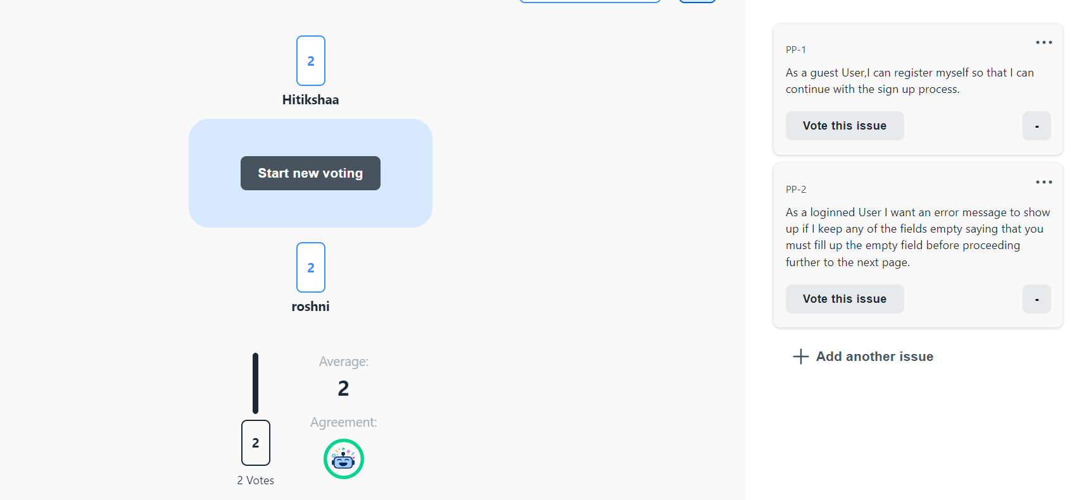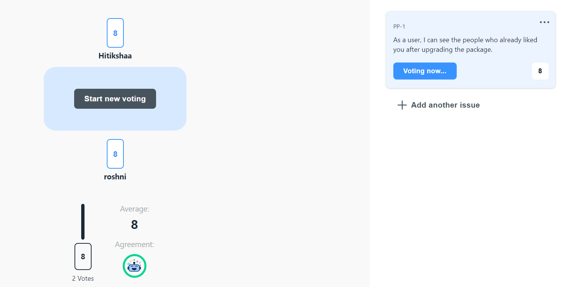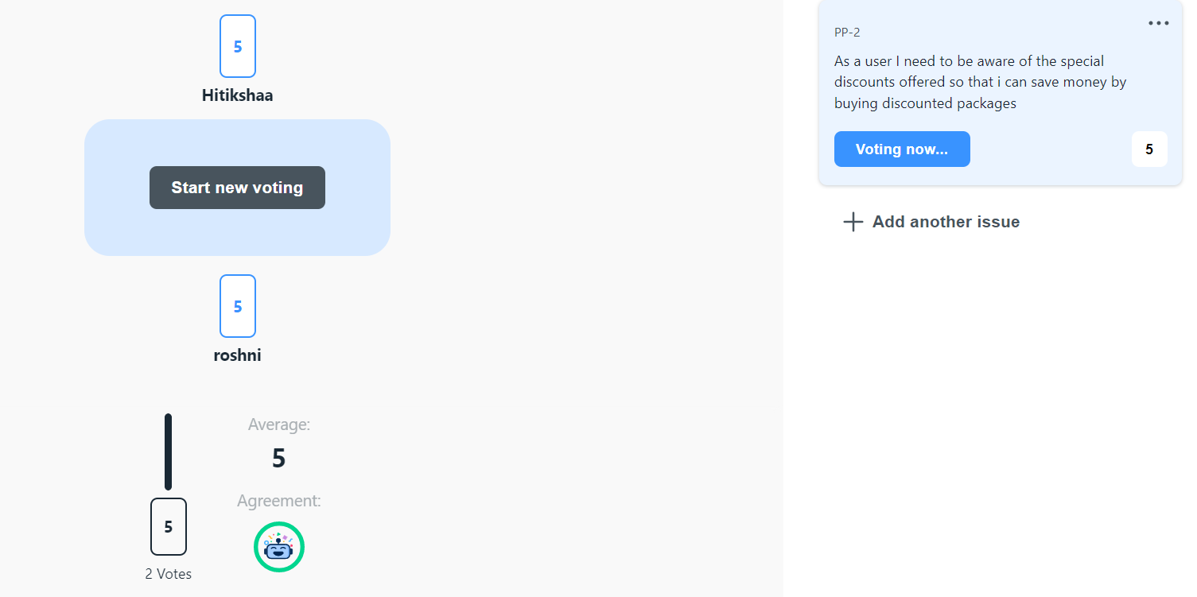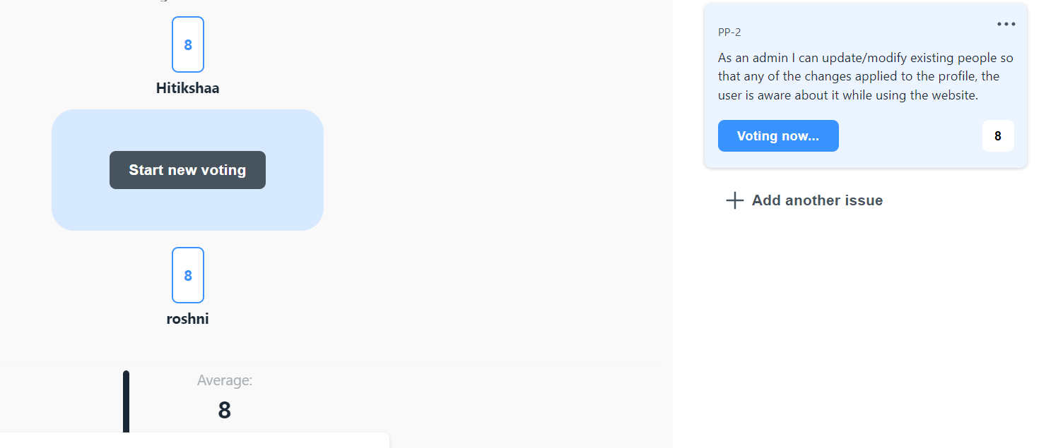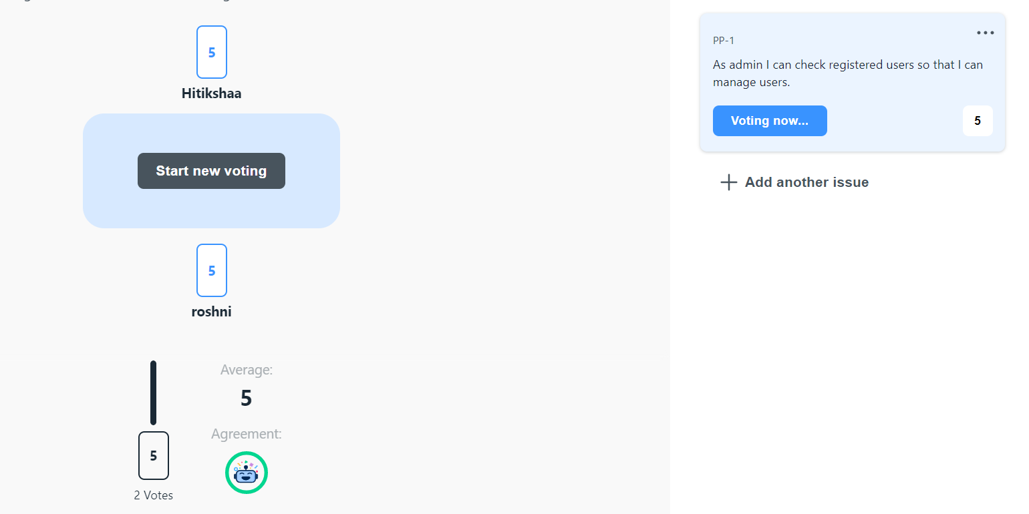

**USE CASE DIAGRAM:**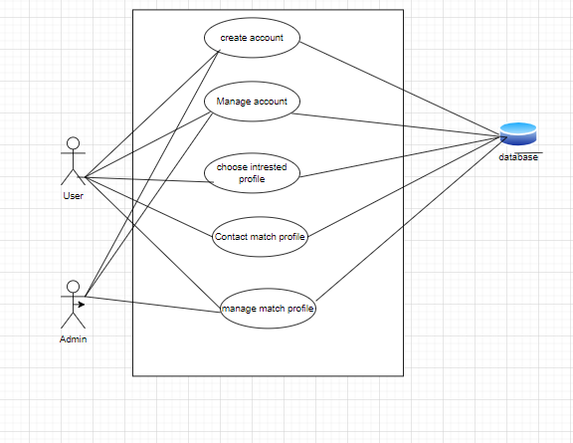

**Fully Dressed Use Case:**

| **Use Case Selection** | **Comment** |
| --- | --- |
| Use case id | UC1 |
| Name | Create Account |
| Actors | User |
| Pre Conditions | 1)User is not an admin.  2)Users are able to open websites and registration pages. |
| Post Conditions | Users will be able to login after registration. |
| Main Success Scenarios | 1)This use case begins when the customer opens a find match as a guest user .  2)The customer clicks on the registration under the account and is navigated to the registration page.  3)The customer fills in all the details and submits.  4)The system checks all the validations and then saves the data to the database.  5)The customer is registered successfully by the system. |
| Alternatives | N/A |
| Special Requirements | N/A |

| **Use Case Selection** | **Comment** |
| --- | --- |
| Use case id | UC2 |
| Name | Manage Account |
| Actors | User , Admin |
| Pre Conditions | User is already registered user or a pre registered admin |
| Post Conditions | User can change information related to their profile |
| Main Success Scenarios | 1)This use case begins when the user or admin opens the managed account page of find match.com .  2)The customer as well as the admin click on the manage account page to navigate to the edit details button.  3)These customers new information will be reflected to the profile page |
| Alternatives | For user admin can update the details using admin rights. |
| Special Requirements | N/A |

| **Use Case Selection** | **Comment** |
| --- | --- |
| Use case id | UC3 |
| Name | Manage Profile |
| Actors | Admin/User |
| Pre Conditions | Admin/User must be login |
| Post Conditions | Admin/User can add and remove auspices user on website |
| Main Success Scenarios | 1)This use case begins when the admin/User opens the managed profile page of find match.com .  2)Admin/User clicks on the managed profile and navigates to the edit button.  3)Admin/User can change the details like edit ,update on the page of the website .  4)Admin/User can upload the photo like edit ,update on the page of the website . |
| Alternatives | N/A. |
| Special Requirements | N/A |

| **Use Case Selection** | **Comment** |
| --- | --- |
| Use case id | UC4 |
| Name | Manage Users |
| Actors | Admin |
| Pre Conditions | Admin must be login |
| Post Conditions | Admin can manage Users in website |
| Main Success Scenarios | 1. The admin logs in to the page. 2. The admin lands on the admin panel. 3. The admin clicks on the check user details on the admin panel. 4. The admin edits the rights of the user. 5. The admin removes i.e., blocks a user. |
| Alternatives | No Alternatives |
| Special Requirements |  |

| **Use Case Selection** | **Comment** |
| --- | --- |
| Use case id | UC4 |
| Name | Find Match |
| Actors | User |
| Pre Conditions | User must be login |
| Post Conditions | User can manage Users in website |
| Main Success Scenarios | 1. The user logs in to the page. 2. The user lands on the find match page. 3. The user clicks on the check user details on the page. 4. The user is able to see the profile of the different user. 5. The user swipes left and right to show they like or not on other users' profiles. 6. The user can see how many people show interest on his/her profile. |
| Alternatives | No Alternatives |
| Special Requirements | N/A |

**ACTIVITY DIAGRAM:**

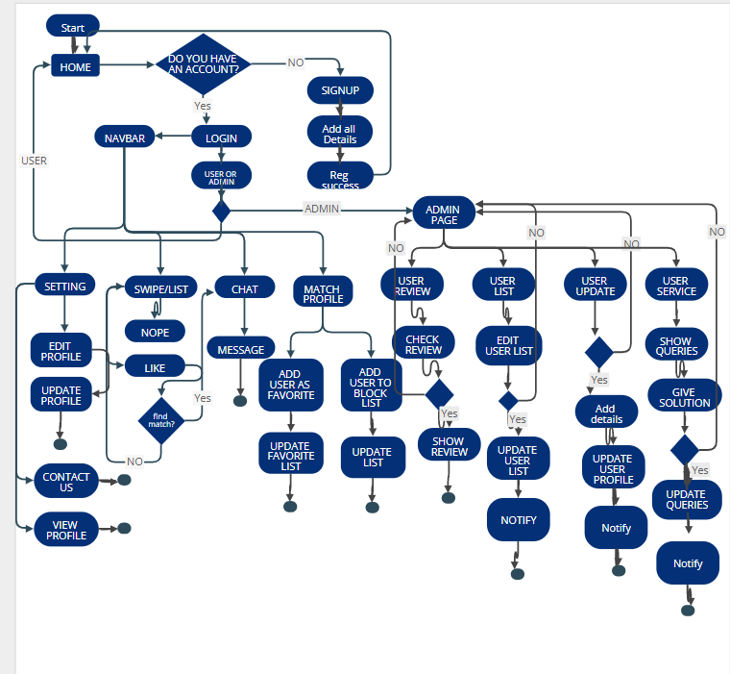

**SEQUENCE DIAGRAM:**

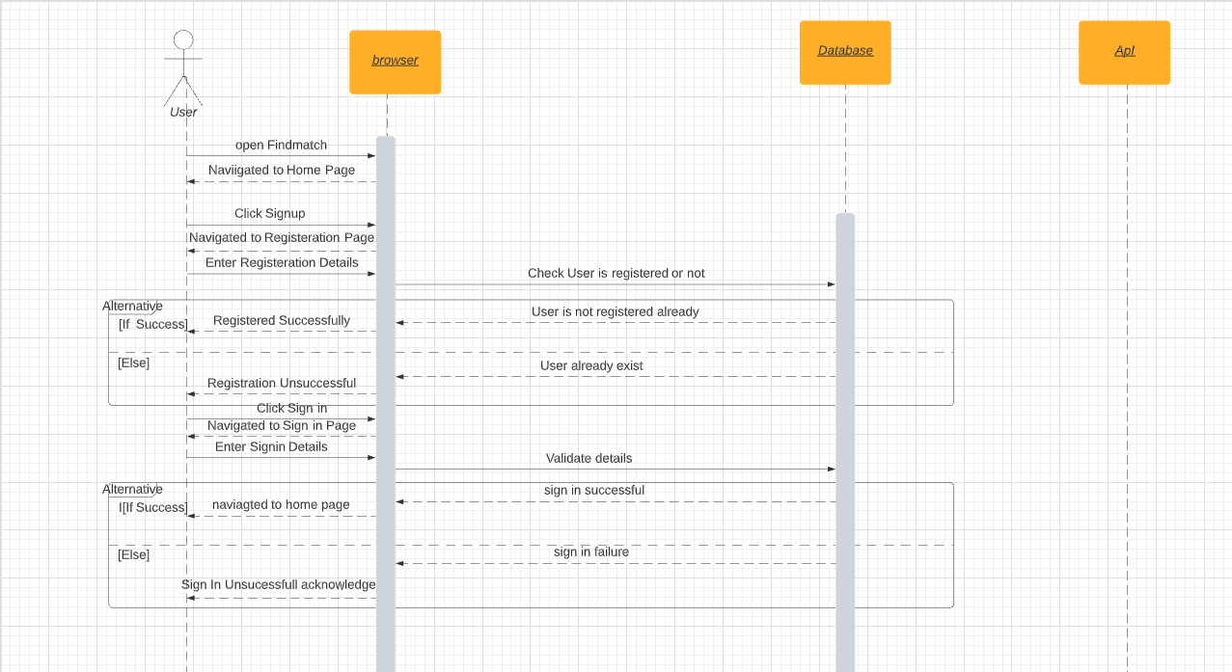

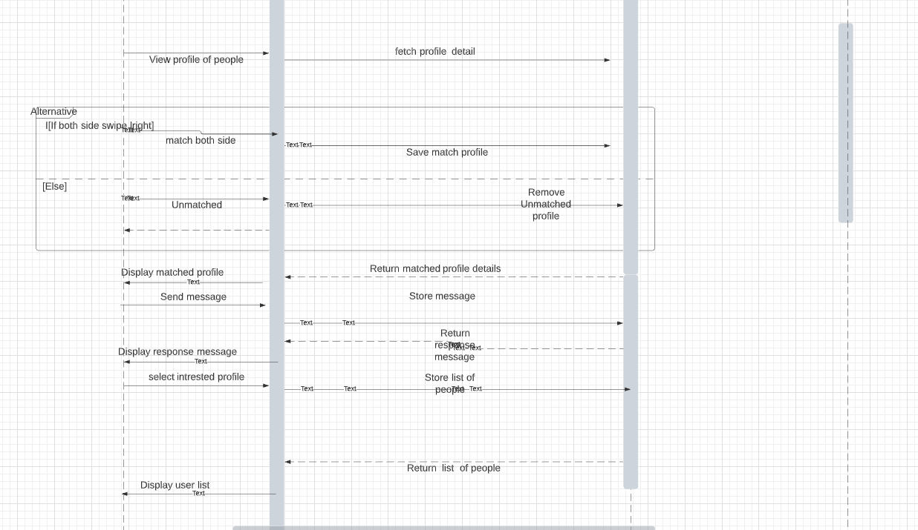

**TEST CASES:**

[TEST CASE](https://docs.google.com/spreadsheets/d/1OHO654UyvE--L4HSxbUYJOFUnNKOytxuSnMTWvK80jU/edit?usp=sharing)

[TEST](https://docs.google.com/spreadsheets/d/1TrBRJvPXD_-nzQ3aS9_qjN_soukeudUICekM-q_uE8k/edit?usp=sharing)